**TEAM ID : PNT2022TMID45173**

**CREATE IBM WATSON IOT PLATFORM AND DEVICE**

1.To create the IBM Watson IOT platform and device

**STEPS:**

1. Create an IBM cloud account with the individual IBMid and password

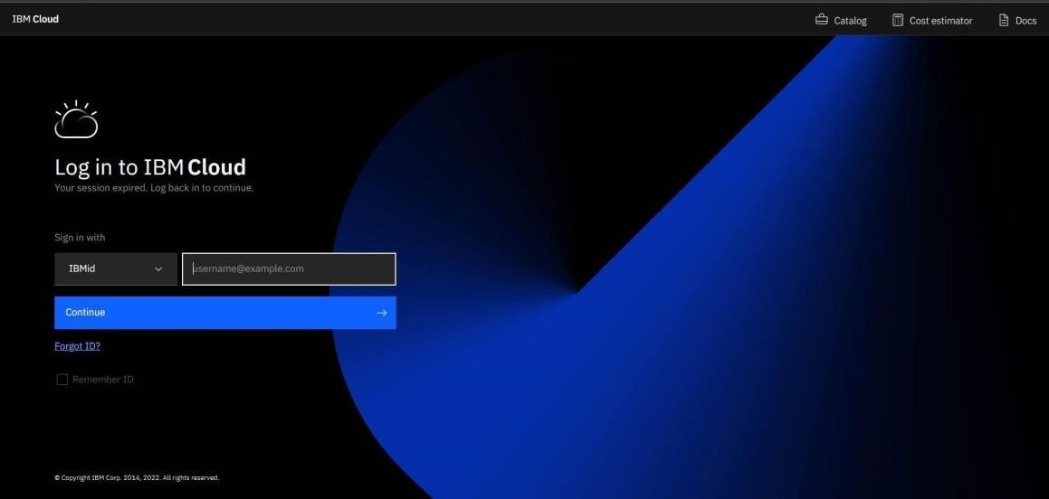

1. HomepageofIBMcloud

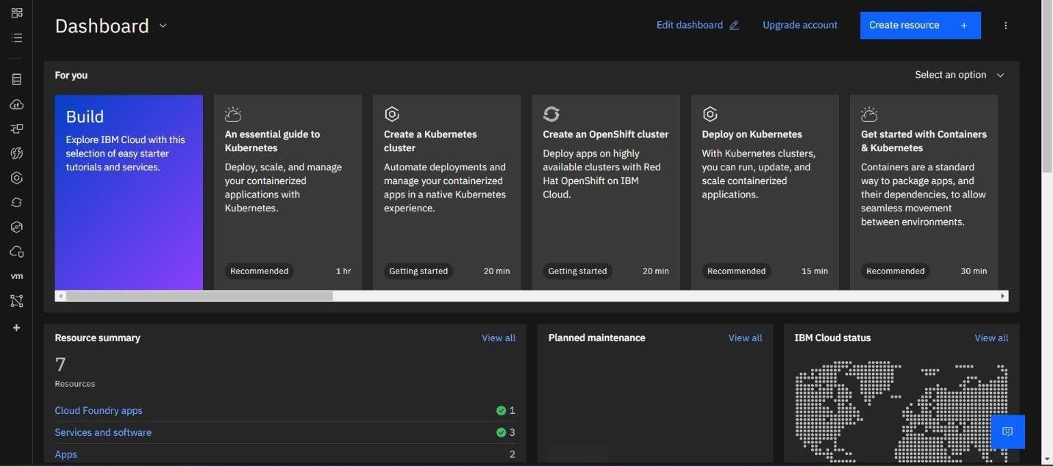

1. Click on the catalog on the top

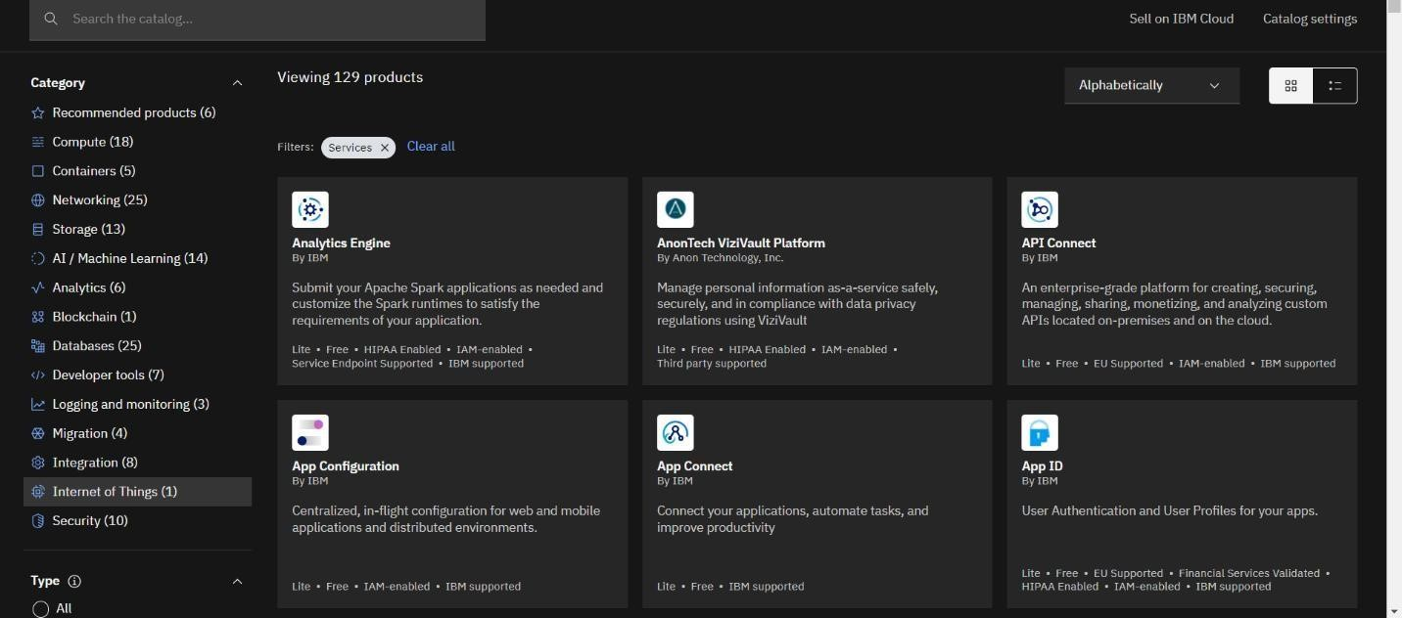

1. Click on IoT in the category mentioned

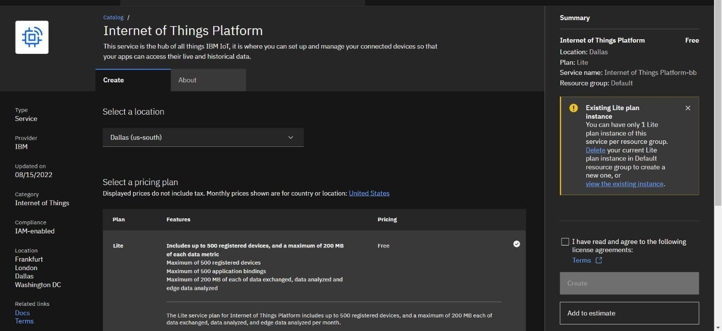

1. If already a lite is present delete it else u can’t create another

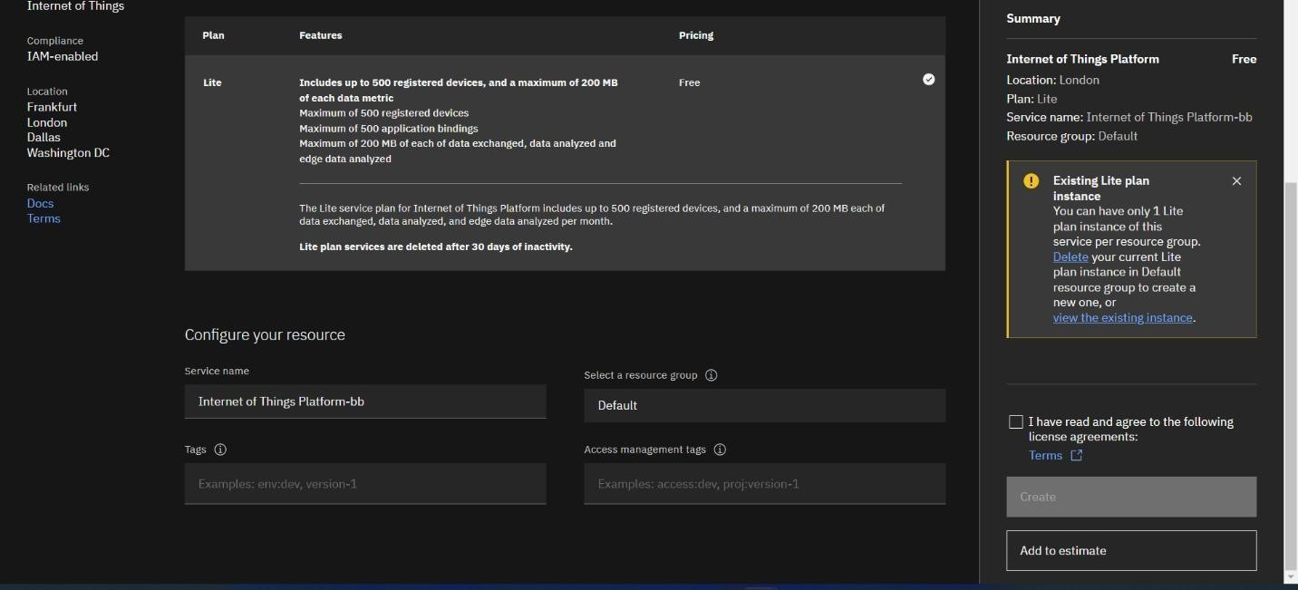

1. Enter the location and in the configure your resource type the service name and choose the plan, tick the agree with agreements and then click on create

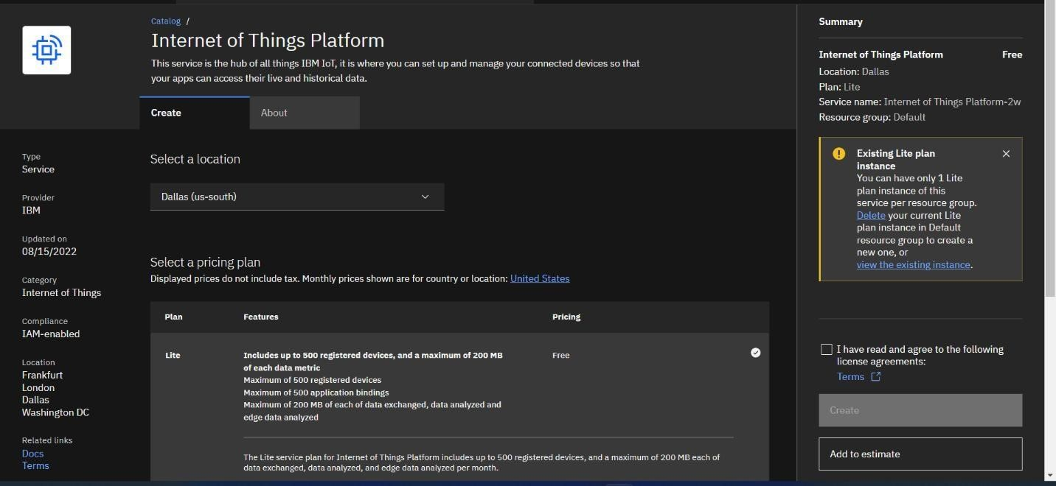

1. Click create

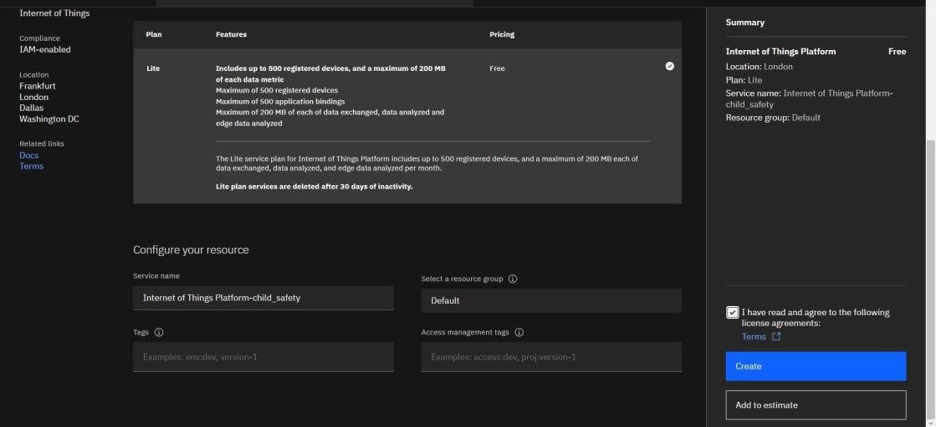

1. Internet of Things Platform crop protection system will be created, where there are different options like manage,plan,and connection

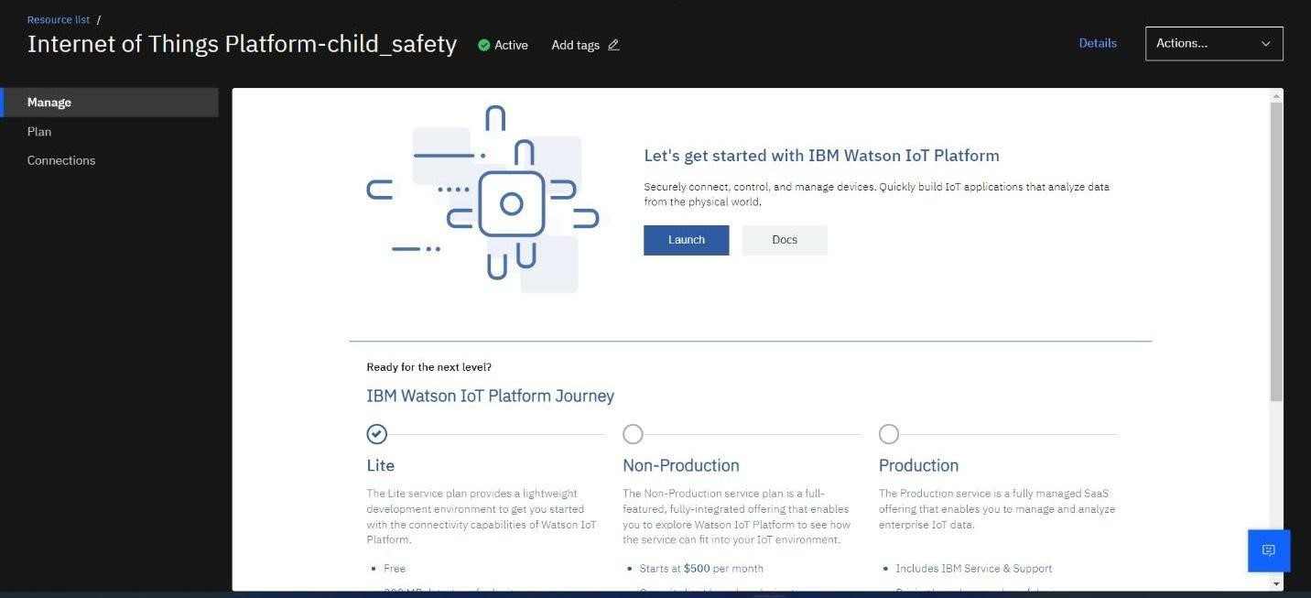

1. manage is for launch, plan gives us the idea about the payment package and its upgrades, and lastly the connection is for to connect IOT with other services

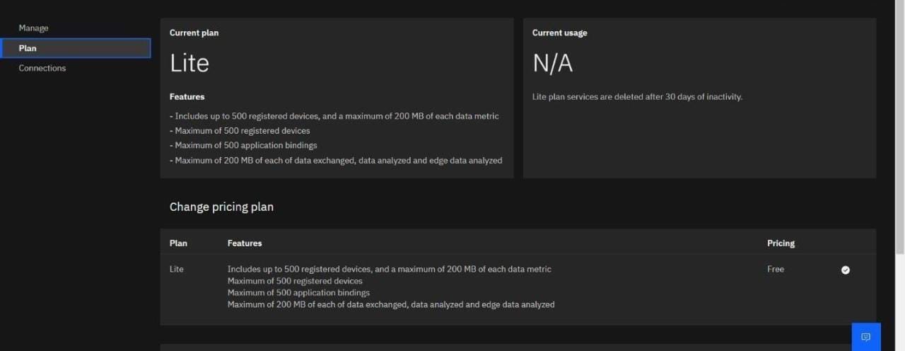

1. Clickonthelaunch buttoninthemanagetab,itwillopentothis

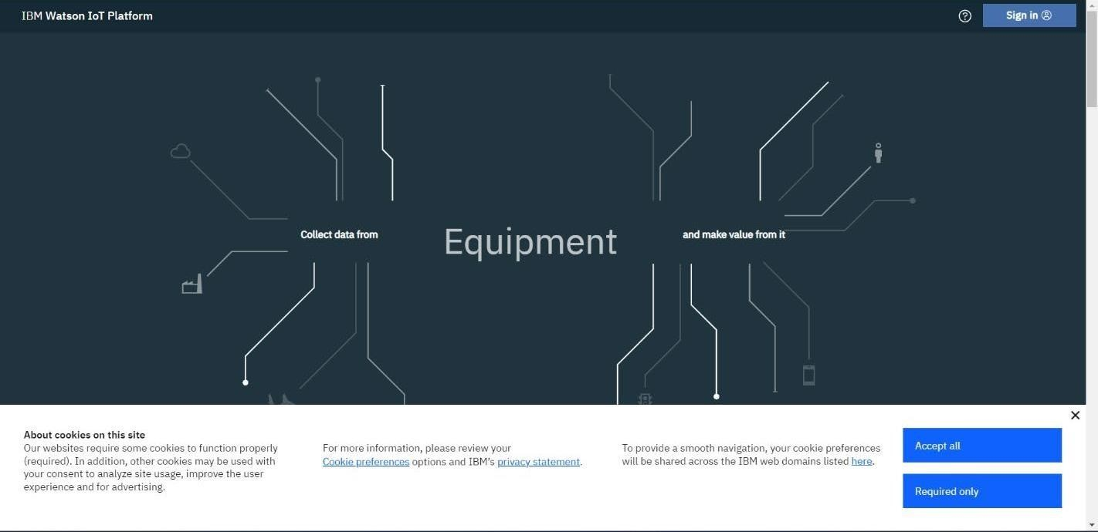

1. Enter the details to signin to the Watson Cloud to create a device

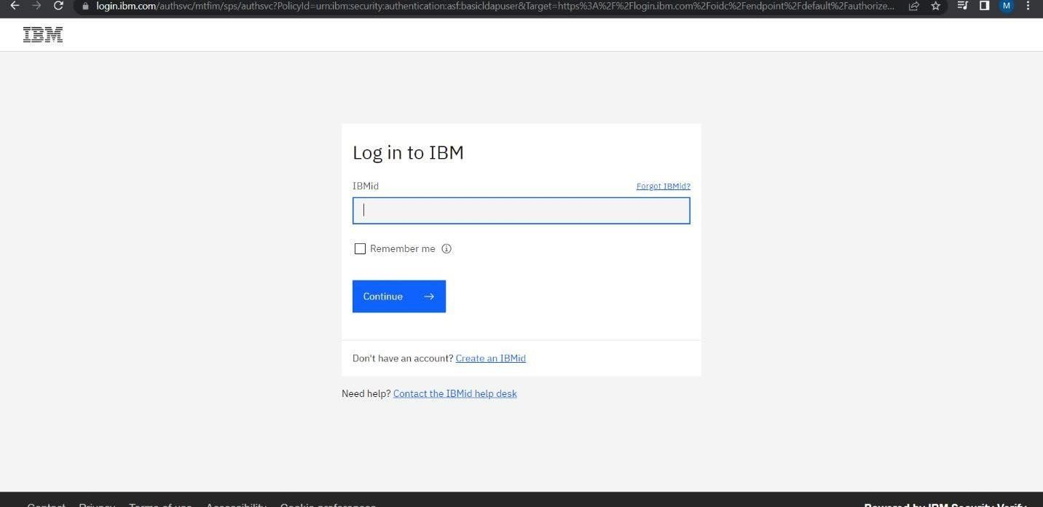

1. Once logged in the name will be displayed and it goes back to the first page

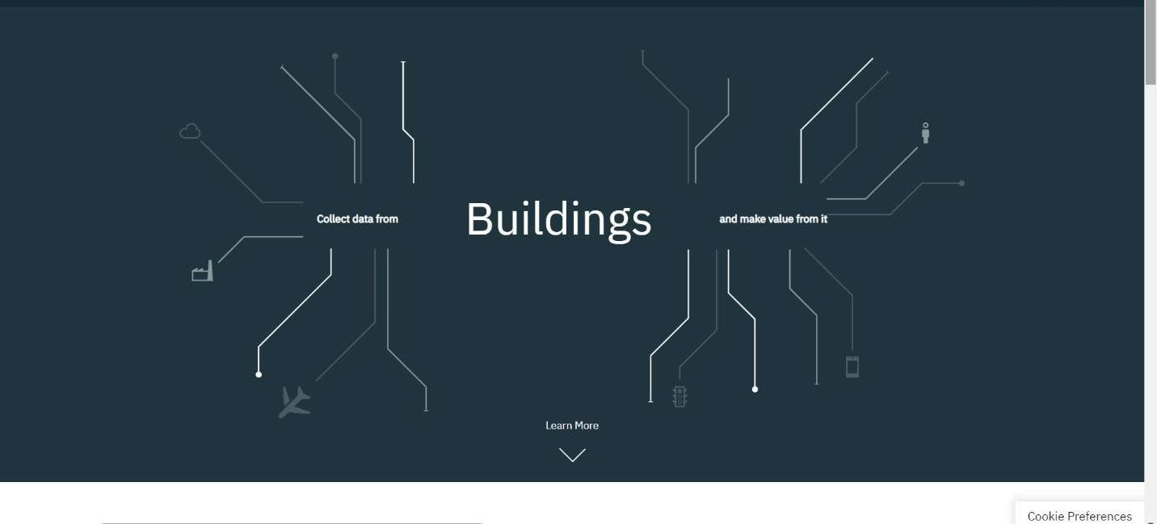

1. And again clicking on the launch button will open this tab, the device will help in the creation of the devices, the addition of devices,and the display of detail soft devices.

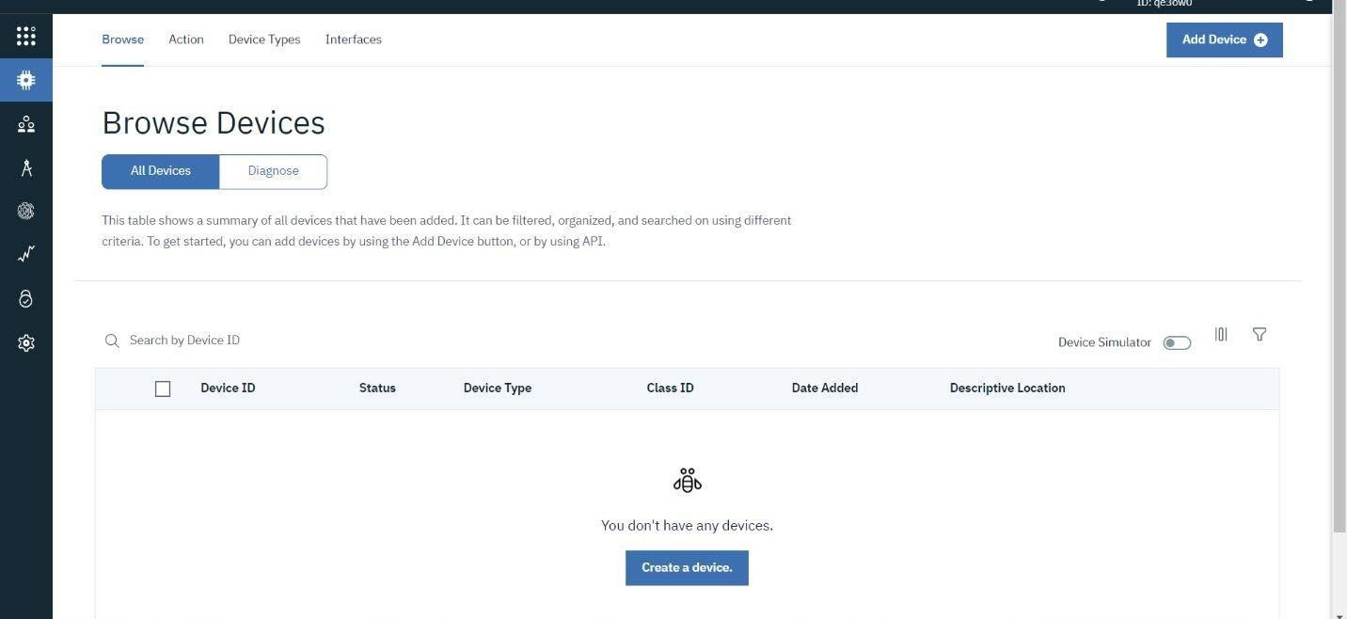

1. The setting tab is used to change the general setting if needed for the project.

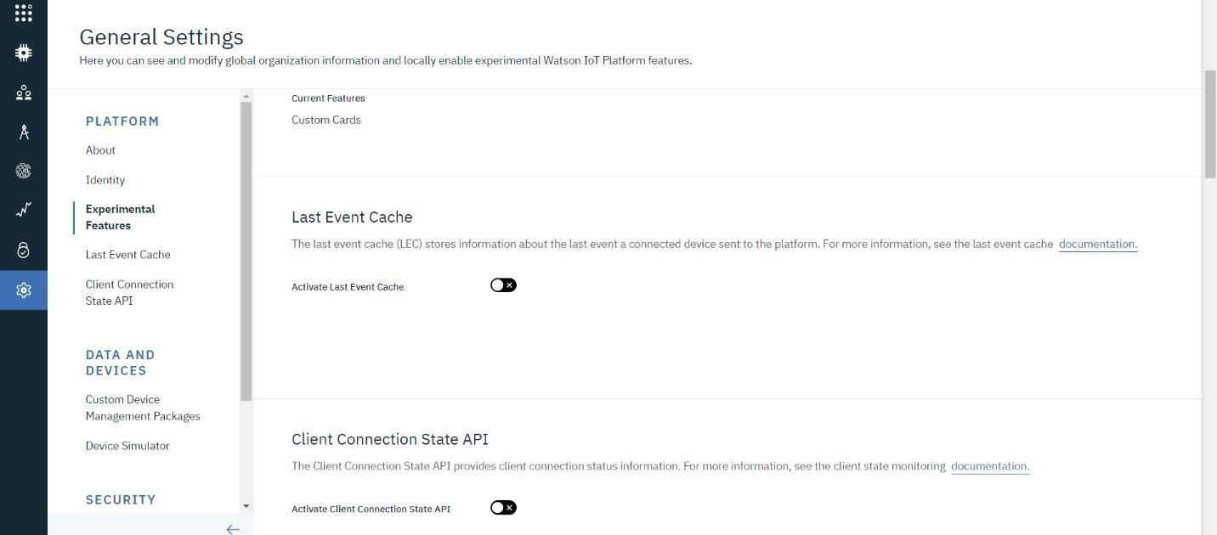

1. In the security tab we can choose the type of security connection and can change according to specification

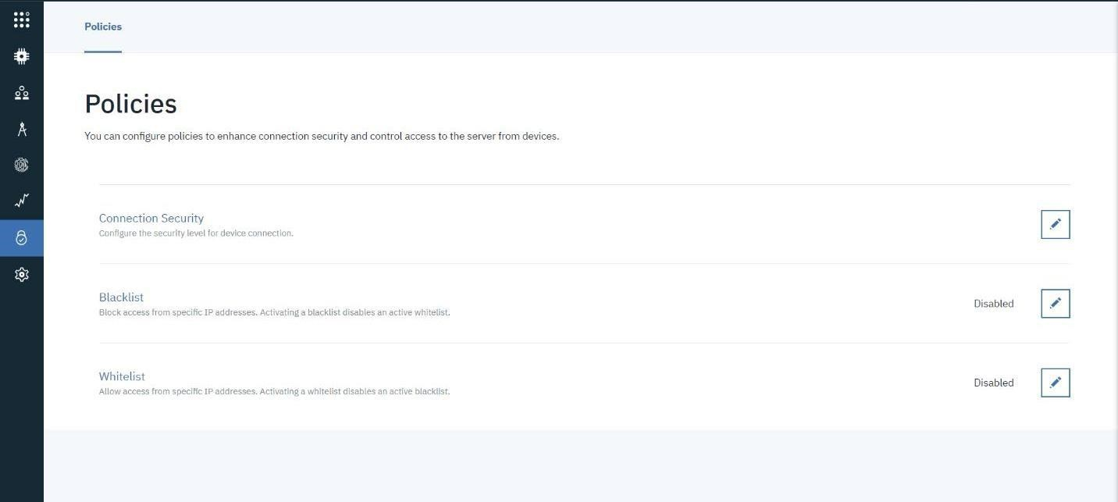

1. Usage gives the summary of how many bytes are used between the devices and the IBM cloud

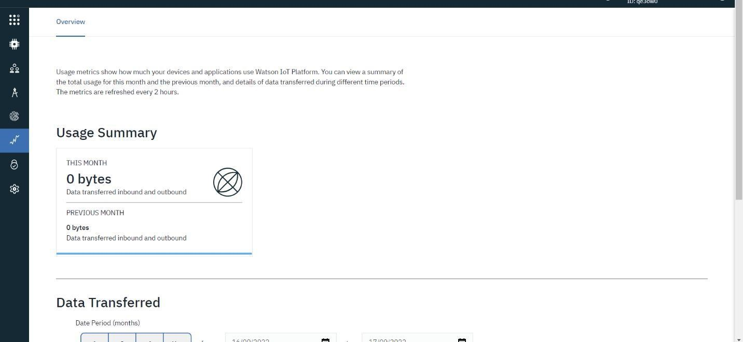

1. The membertabisaddtheteams memberstoworkintheplatform

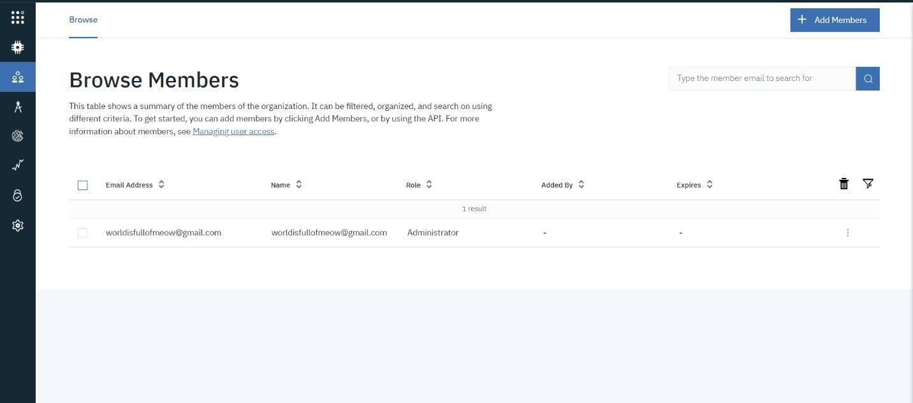

1. This tab is used when you want to connect to some other platformandtointegratewithotherservices.

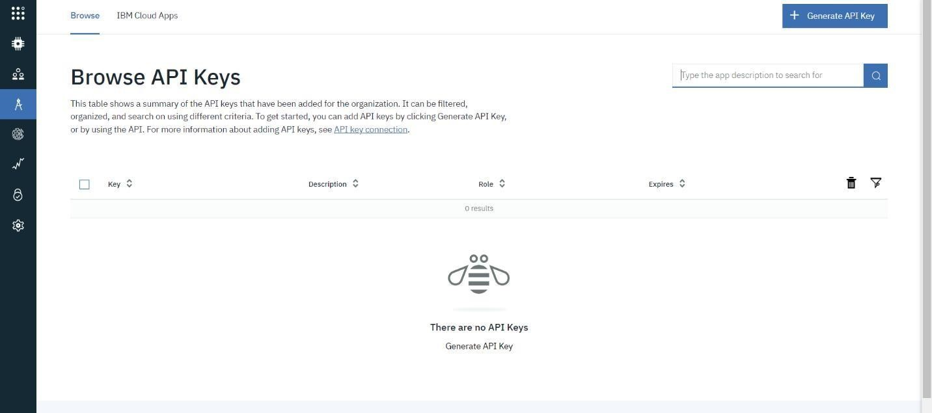

1. Click on the device tab and click on the add device button, then give the device type and device id and click next

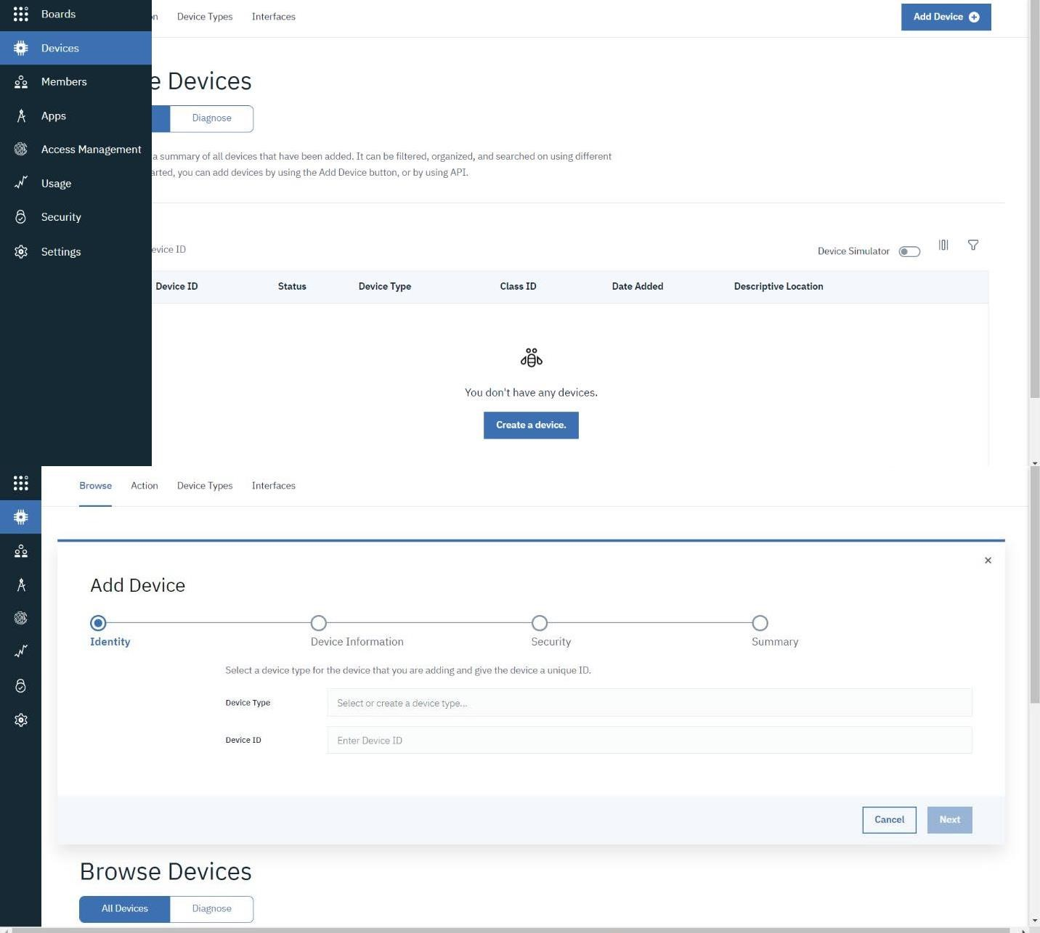

1. This page to ente extra detail sand of the hardware

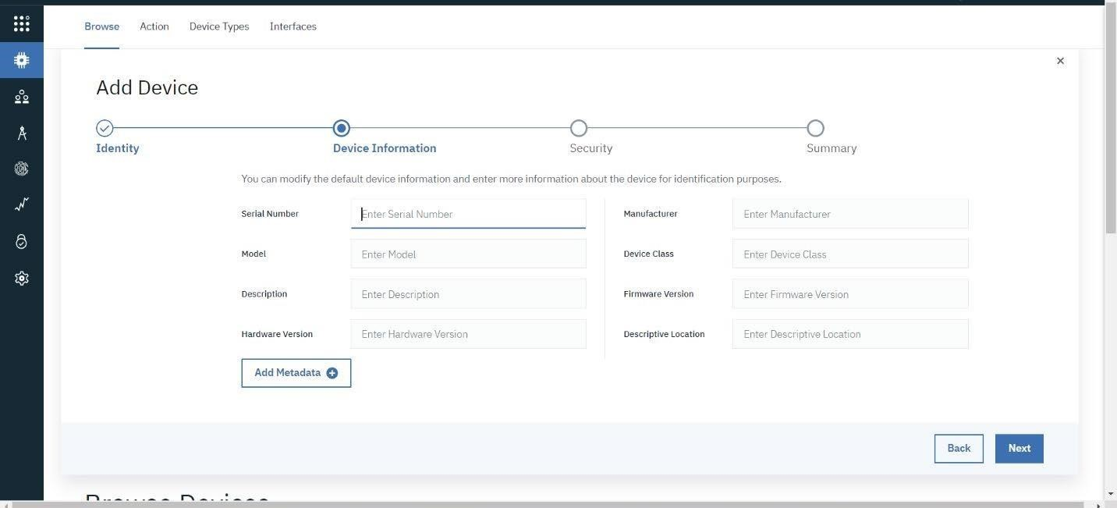

1. Clicking next it goes to the security where we do authentication to kenid.

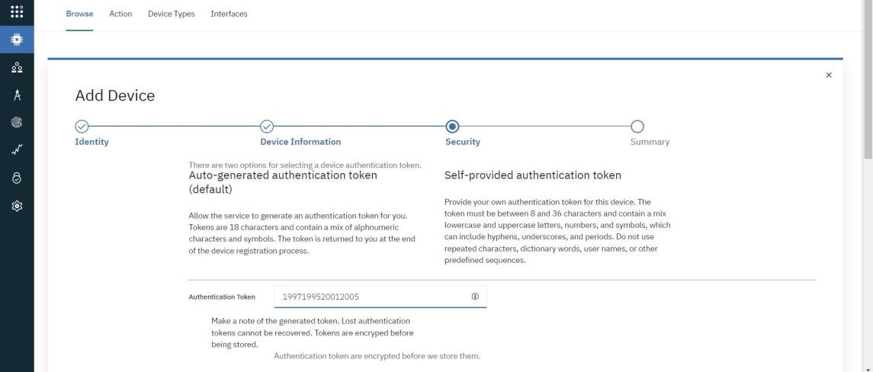

1. Clicking on next it goes to the summary of the device then click finish

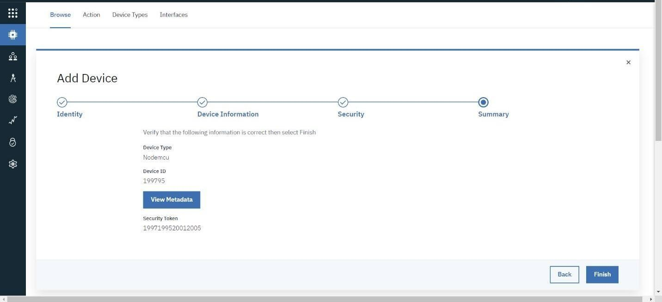

1. Thedevicecredentialswillbedisplayed withallthedetails
2. Safe the details of the device as the authentication tokens are nonrecoverableandifmisplacedthenwe havetocreatea newone.

25..Clicking on the device tab we can now see the added device. Clickingon it will display the other details. It has different tabs like Identity,DeviceInformation,Stateandlogin.

In a similar way, we can create n number of devices with a 50 per pagelimitas pertherequirementofourproject

26. TheBoardswilldisplaycardfortheproject.

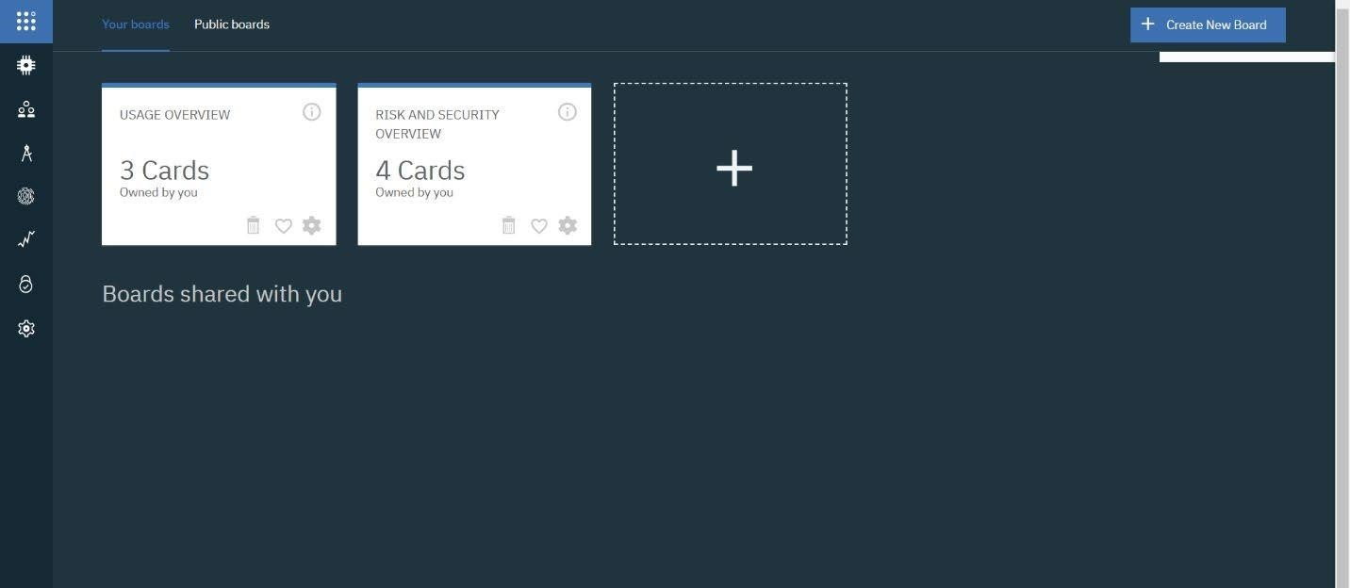

**CONCLUSION:**

An IBM Watson cloud for IoT and a device is created